Comms Process Starter/Config Design Document

Security Classification: | Internal
Document Reference: | N/A
Status: | Released
Version: | 2.0
Team/Department : | Networking
Author(s): | Thomas Goodfellow
Owner(s): | Networking TA

Approver(s): | <Names> | Distribution: | <Names>

Contents
1 Introduction 3
1.1 Purpose and Scope 3
1.2 Requirements 3
2 Design Overview 3
3 Detailed Design 4
3.1 CCommsProcessStarter 5
3.1.1 CMI file format 6
3.1.2 ReadConfigAndStartAllL() 9
3.1.3 GetModule() 9
3.1.4 NotifyLoadCompletion() 9
3.1.5 NotifyBindCompletion() 9
3.2 CModuleRef 9
3.2.1 NewL() 10
3.2.2 State() 10
3.2.3 Load() 10
3.3 CBindingRef 10
3.3.1 NewL() 10
3.3.2 State 10
3.3.3 BindIfReady() 11
4 Scenarios 11
4.1 CRS not running 11
4.2 Complete sequence with a SuddenDeath 12
5 Global Configuration Options 13
5.1 MBufPoolSize 13
5.2 TestMode 13
6 Design Considerations 13
6.1 Handling CPM “sudden death” 13
6.2 Memory footprint 13
6.3 Platform Security 14
6.4 Life-long configuration process 14
6.4.1 Failure tolerance 14
7 Further Information 14
7.1 People 14
7.2 References 14
7.3 Open Issues 15
7.4 Glossary 15
7.5 Document History 15

Introduction

Purpose and Scope
This document gives the design for the Comms Roots Server Startup / Configuration Process (SCP). The CRS design [R2] and the GT167 project documents are the reference for the requirements of this process.

Requirements
The SCP is responsible for:
- Starting the Comms Root Server
- Reading configuration files, loading the configured Comms Provider Modules, and binding them as configured.
- Listening for “sudden death” of the loaded CPMs and reacting appropriately. Note that “sudden death” is a slight misnomer; see section 6.1.

Design Overview
The SCP runs as a client with the NetworkControl capability [R3]. It is launched during the device boot, connects to the CRS, and keeps running until after the CRS terminates (which it usually never does).
The CRS is started by the C32Start process, which implies that C32Start is run before the CRS in the boot process. However even with such a proviso there is necessarily a delay between the execution start of C32Start and the CRS being ready for connections. This has been addressed by having all the server modules block their startup upon the completion of the CRS startup. This completion is signalled via the publishing of a property, which must be signalled before all modules are started (see 3.1.1.9 for specifics).
Configuration files are discovered and processed to load the CPMs (both protocols and servers). Loading is an asynchronous process, so as each CPM completes loading the SCP evaluates its pending bindings and asynchronously requests any that have now become possible. By doing this asynchronously and opportunistically, we avoid stalling the provision of Comms facilities in the case where a CPM is unnaturally slow to start (hypothetical case once NIFs can be CPMs: IP is bound to both an Ethernet NIF and an Inmarsat satellite-link NIF and the latter takes three minutes to complete startup; prior to that local networking should be available).
Once all the asynchronous requests for loads and binds have completed the supporting data could be discarded (see Memory Footprint section below). The notification loop then continues processing Sudden Death notifications (see CPM Sudden Death section below).
C32START is launched, either specifically from the SSA System Starter as part of OS Services Domain 3 (the usual case unless SysStart is suppressed or a system dependency pre-empts this), by explicit call to StartC32() or implicitly by connecting a server session such as RSocketServ. It then:
- Reads all .CMI files in its private directory.
- Starts the RootServer and connects to it
- Connects to the SSA domain and subscribes to start-up state notifications
- Loads all of the CPMs described in the sequence specified, creating any bindings specified once both modules involved complete loading. The start-up sequence numbers now map to SSA start-up states and C32START only loads modules appropriate to the current state, waiting for the published state to appropriately advance before loading others.
- A new StartC32() overload is added to allow the caller to specify the module to block until loading is completed. The default behaviour remains blocking until all of ETEL, ESOCK, and C32 have loaded.
- After all CPMs have loaded C32START remains resident and connected to the RootServer waiting for module deaths or warm-boot requests.
- Before module configuration is completed, if an ESOCK Dealer receives a client request requiring a protocol which isn’t currently available it must add the request to a “holding queue” for later completion, when further ESOCK modules are loaded or configuration is complete. Requests requiring protocol information include creating sockets and getting protocol information. A few requests such as RSocketServ::NumProtocols() can only be completed once configuration is complete.
C32START then remains resident and connected to the RootServer waiting for module deaths or warm-boot requests

Detailed Design
This design attempts to provide the required functionality with slender hooks for plausible future needs. Many of these “hooks” are conceptual: the only mechanism for starting is ReadConfigAndStartAllL() but we might expect future needs to add methods for starting and stopping individual modules.

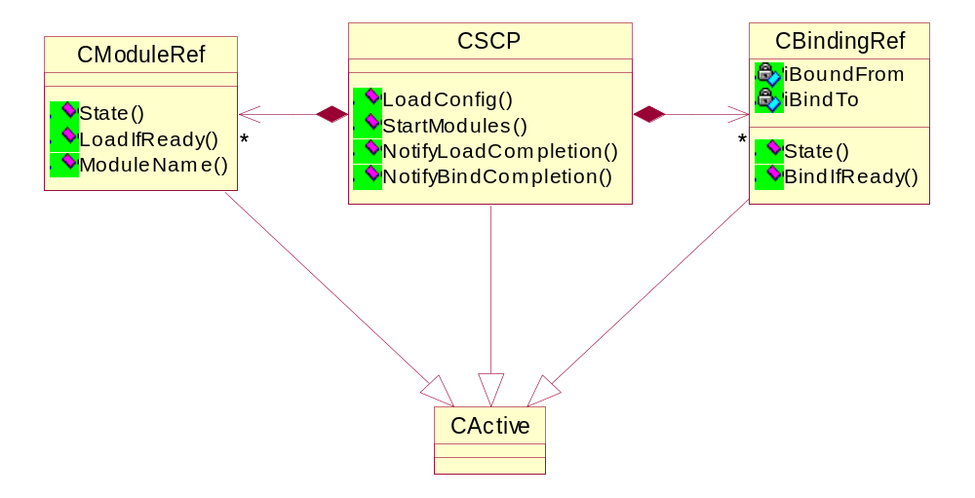

Class name | Description
CCommsProcessStarter | Main class for the SCP. Provides the public interface
CModuleRef | Represents both Provider Modules and Server Modules
CBindingRef | Represents a binding between two Modules

Modules are loaded following the “Scaled Start-up State” specified in their configuration. This is the Start-up State of the SSA scaled by multiplying by KC32StartupStateScalingFactor (0x100) and serves both to give the sequence in which modules load (the ascending value sequence. Modules with the same value are loaded concurrently) and to load modules in the system-wide Start-up State appropriate. For example in the reference configuration some ESOCK modules are loaded at “non-critical dynamic” to remove them from the system boot’s critical path.
TRSStartState provides backward-compatible startup levels for specifying in what sequence CPMs are loaded:
enum TRSStartState
{
/** The Rootserver is initialising.
*/
EInitialising = 0,
/** Core system components such as the socket server are running and configured.
*/
ECoreComponentsStarted = 10,
/** All configuration has been applied
*/
EConfigurationComplete = 32,
/** The Rootserver should be reconfigured by the configurator (aka warm booting)
*/
EReset = -1
};
where StartC32() blocked until ECoreComponentsStarted was reached. We expand the range of SSA start-up states by multiplying those constants by 0x100 so that the load order for a group of CPMs within a start-up state can be specified, this becoming the “scaled start-up-state”.
For example the initial start-up state could be ELicenseeState1 == 0x04, at which point CPMs with startup sequences 0x0 – 0x4FF would be loaded in ascending order. The next startup state might be EStartupStateCriticalStatic == 0x10, triggering the load of sequences 0x500 – 0x10FF.
Once all modules have been loaded the startup state is advanced to EConfigurationComplete to indicate to observers such as ESOCK that configuration is complete.
The KC32StartPropertyKey is still published, again to avoid compatibility breaks. The emulation is limited to publishing:
- ECoreComponentsStarted (10) when the ScaledStartupState is > 0x2000
- EConfigurationComplete (32) when all modules have loaded
since we cannot in general expect finer-grained start-up states than the Symbian-specified ones, and these ones are the most important ones of “core modules loaded” and “all loading complete”.
The whole SCP process runs in a single thread with a CActiveScheduler. All of the interesting functionality is in these classes; the E32Main of the SCP installs a scheduler, creates the CCommsProcessStarter, and calls ReadConfigAndStartAllL() upon it.
CModuleRef and CBindingRef objects both transition from being untried to pending to end states of either successful or failed. Upon reaching these they notify the CCommsProcessStarter object. The CCommsProcessStarter object reacts to module load notifications by requesting binding.
Modules have the option to use a private heap, or share another CPM’s heap. This will be indicated in the CMI file, in the form of an enum type TRSHeapType: EDefaultHeap, EShareHeap, ENewHeap. The EDefaultHeap type, specifies that the CPM uses the Root Server’s own default heap. The EShareHeap type allows for a CPM to share another CPM’s heap. If this is specified, the CMI file is also expected to contain the name of the CPM whose heap this CPM would like to share with. ENewHeap specifies that the CPM would like to use it’s own new heap. However, there can only be a maximum of 8 heaps in the Root Server process, so if no new heaps are available, then a load with new heap will fail with ERSNoNewHeapsAvailable.

CCommsProcessStarter
class CCommsProcessStarter : public CDmDomain
{
public:
void ReadConfigAndStartAllL();
CModuleRef* GetModule(const TDesC& aName);
virtual void NotifyLoadCompletion(CModuleRef& aModule);
virtual void NotifyBindCompletion(CBindingRef& aBinding);
};
CCommsProcessStarter derives from CDmDomain to provide the SSA change notifications required. CCommsProcessStarter::StartLoading() to start loading all modules at the current start-sequence, and uses the load and bind completion notifications to trigger ascension to the next sequence. This ascension is gated with the SSA change notification so that the criteria for ascension is:
- zero outstanding module loads
- zero outstanding binds
- CurrentScaledStartupState > next unloaded module’s ScaledStartupState. This requires that the modules are sorted into ascending ScaledStartupState.
The CurrentScaledStartupState is derived from the current StartupState (retrieved by CDmDomain::GetState()) * 0x100 + 0xFF.
These criteria are all independent and arrive asynchronously, via NotifyLoadCompletion(), NotifyBindCompletion(), and RunL() respectively. When the first two are satisfied CDmDomain::AcknowledgeLastState(KErrNone) is called.
A CActive-derived helper class is required to monitor for sudden death notification, calling CCommsProcessStarter::NotifySuddenDeath() which is the body of the present RunL().
The discovery and processing of configuration files for the SCP is similar to that of .ESK files by the single-threaded ESock’s ProtocolManager. Each CPM or Comms Server has a separate file: this eases configuration since replacing/moving/deleting a whole file is more foolproof than editing sections of a single file. Each configuration file specifies the module name, initialisation data (which may often be the name of a separate file), optionally the desired priority for the CPM’s main thread, and optionally a list of bindings (for CPMs only). The module name must be unique (applying the definition of uniqueness of [R2]); any duplicates are expressly ignored – in this initial design the SCP will panic upon a duplicate module name, however licensees may wish implement cleverer behaviour.
Configuration files use the well-understood INI file format of “key=value” pairs inside blocks headed with “[section]”, and are identified by having the extension “.CMI” (comms module INI). The risk of conflict between this extension and some other customary use is mitigated by the fact that the configuration files will all be in the SCP’s private data-caged directory.
Such files are supported by the CIniFile class, which at present can only be constructed from a file. The proposal is that support for construction from a TDesC8* is added, so providing a good default processor for protocol writers without forcing them to adopt it.

CMI file format
Every CMI file contains a [Loader] section, which contains all of the directives for the SCP processing. Optionally they can also contain a [IniData] section, then content of this section is read and delivered in 8 bit form to the CPM as part of the parameters to the main thread function. Note in particular that the data in the [IniData] needn’t follow INI file formatting, everything from the section header to the end of the file is simply passed to the CPM.
Within the [Loader] section the recognised keys are:

Name
Mandatory. The value specifies the server or CPM name to use in all references to this module, eg when enumerating loaded modules. Must be unique.

Filename
Mandatory. The value nominates the host DLL containing the server or module.

IniData
Optional. When present the value is the name of an initialisation file whose contents are loaded into a descriptor and passed the CPM as part of the parameters to the main thread function. The usage of this key overrides the usage of a IniData section within this file.

IsServer
Optional. When present and with a value other than 0, specifies that this CPM has status as a server, meaning that hierarchical binding can only be with this module as the upper module.

IsSticky
Optional. When present and with a value other than 0, specifies that clients can not request the module to be shut down. The RootServer will return KErrLocked on such requests.
Defaults to 0 – module can be unloaded.

ThreadFunctionOrdinal
If not specified, or set to 0, it is assumed that the main thread function of the CPM is the default ordinal (which is the first ordinal in the export table - ordinal 1). If set to an integer number >0 the corresponding ordinal of the CPM DLL will be used as the main thread function. Anything else than 0 or a positive number is illegal.

Priority
Optional. When present the value is an string value corresponding to the TThreadPriority enumerated type. The results of setting it to any other value will result in a KErrCorrupt error code.

StackSize
Optional. When present the value is the integer size for the module’s main thread’s stack in bytes.

StartSequence
Optional. When present the value is the integer start sequence. This is the legacy way of controlling the module start-up point and is translated into the ScaledStartupState:
StartSequence | ScaledStartupState
0 – 4 | 0x1040 + SSeq
5 – 10 | 0x1080 + SSeq
> 10 | 0x3040 + SSeq
The intent being to provide an approximation of the start sequence they expected (C32, ETEL, and ESOCK all started at sequence 5).
Modules should use the ScaledStartupState in preference (finer control).

HeapOption
Optional. When present controls whether the module is loaded with a new heap, attempts to share a heap, or simple uses the Root Server’s heap. If not specified, the CSP load the CPM using the default heap. Can be one of three strings:
- EDefaultHeap, use the default shared heap for the process.
- EShareHeap, use the same heap as module defined by the option ShareHeapWith.
- ENewHeap, create module with a new heap.

MinHeapSize
Optional. If HeapOption is not ENewHeap this section is ignored. When present specifies the minimum size in bytes of the CPMs heap.

MaxHeapSize
Optional. If HeapOption is not ENewHeap this section is ignored. When present specifies the maximum size in bytes of the CPMs heap.

ShareHeapWith
Optional. If HeapOption is not specified as EShareHeap, this section is ignored, otherwise it is mandatory. When present specifies which CPM to share a heap with.

BindingN
Optional and may occur multiple times (where N is the zero-based and consecutive binding number). The value is formatted:
<Upper SubModuleName>,<Lower SubModuleName>,<Bind Type>

where the both names are the fully qualified sub-module names and the bind type either:
- EHierarchical
- ECustom
See [R2] in particular for details of binding types. Note that the foreign sub-module must be bindable with regard to load sequence (see 3.1.1.9), ie it must have an identical or lower sequence or the CSP will panic. This requirement occurs to avoid deadlock – a higher sequence module cannot be loaded until the binding of lower sequence ones is complete. This requirement may seem constraining, however it should be noted that the sequence mechanism is provided to support unusual requirements and that most modules can use the default. The rule is to always bind from the higher sequence to the lower sequence, ie if the relative sequences are inverted then move the BindingN from the one to the other.
Note also that the number N serves purely to distinguish between multiple bindings in the INI file syntax (where keys must be unique). In particular it in no way specifies an ordering: each binding will be attempted once both endpoint modules are ready. The choice of zero-basing is deliberate; if by mistake the first binding is named Binding1 then no binding at all will be performed, which should prove conspicuous.

ScaledStartupState
Optional. When present the value is the integer SSA start-up state, scaled up by KC32StartupStateScalingFactor (0x100).
Module startup progresses from zero upwards and all modules/servers of the same value are started simultaneously, with no module of a higher sequence starting before all lower ones have started. Furthermore a module is not started until the system start-up state encompasses it. E.g. if the start-up state is EStartupStateCriticalStatic (0x10) then only modules with scaled start-up state <= 0x10FF are able to start. “Started” means both the load attempt and all bind attempts have completed. Furthermore, the completion of the CRS startup is signalled when all modules with StartSequence <= 10 have started.
This mechanism is provided to allow for:
- Private load dependencies not adequately controlled by binding, e.g. if some daughter module must have its parent loaded first.
- Removing modules from the system’s critical path when booting. This allows unnaturally slow modules (the satellite bearer conjectured above) to avoid blocking connectivity. A client is likely to be more tolerant of the temporary unavailability of a bearer than of the absence of ESock.
If no ScaledStartupState key is present then the default of 0x3000 is used, ie non-critical.
It is an error to specify both a StartSequence and a ScaledStartupState, since the latter replaces the former.

A sample (hypothetical!) file for a TCP/IP module:
[Loader]
Name=TCP6
Filename=TCPIP6.PRT
IsServer=0
ThreadPriority= EPriorityNormal
StackSize=32768
ScaledStartupState=0x1080
HeapOption=EDefaultHeap
Binding0= CSocketServer:ProtMan,IP6:TCP, EHierarchical

[IniData]
...

ReadConfigAndStartAllL()
At present this is the sole control point: the actor calls this to begin the process of loading and binding. This is an asynchronous process with no provision for cancellation, notification of completion, or reversal (ie there is no Stop or StopAll), though expansion of the SCP requirements would add this.
This connects to the CRS and leaves if it can’t, both for a context in which the module loading and binding can proceed and to start the sudden death listening, for which the object becomes active.
Uses: RRootServ::Connect(), RRootServ::SuddenDeathListener()

GetModule()
Returns a pointer to the named module or server’s CModuleRef, or NULL if not found.

NotifyLoadCompletion()
Called by a CModuleRef to signal the completion of that module’s load attempt. The CCommsProcessStarter then enumerates the bindings and requests all unbound ones to BindIfReady() – the readiness is assessed by the CBindingRef.

NotifyBindCompletion()
Called by a CBindingRef to signal the completion of that binding’s bind attempt. At present the CCommsProcessStarter does not react to this; it is present in the design as it seems like a very probable future requirement.

CModuleRef
class CModuleRef : public CActive
{
public:
enum TModuleType { EServerModule, EProviderModule };
enum TModuleState { ENotLoaded, ELoading, ELoaded, ELoadFailed };

static CModuleRef* NewL(CCommsProcessStarter& aSCP, const TDesC& aName, TModuleType aType, HBufC8* aIniData);
TModuleState State() const;
void Load();
};

The small number of interrogation functions is deliberate: this class is not a generalised representation for a CRS module.

NewL()
Standard factory function; returns a pointer to the CModuleRef, which has been initialised from the provided parameters. aIniData contains the contents of the .CMI file and the CModuleRef instance takes ownership of this, ie it must delete this once the load attempt is complete.

State()
Returns the current state:
ENotLoaded | No load has been attempted.
ELoading | Loading of the module by the CRS has been requested but has not completed.
ELoaded | Loading of the module by the CRS completed successfully.
ELoadFailed | Loading of the module by the CRS completed with failure.

Load()
Requests the CRS to load the module using the parameters provided on creation of the CModuleRef (distinguishing between servers and CPMs), then sets the state to ELoading and sets the object active. The completion of the object by the CRS then advances the state to ELoaded or ELoadFailed.
Panics if called in the ELoading or ELoaded state.
Uses: RRootServ::LoadServer(), RRootServ::LoadCpm()

CBindingRef
class CBindingRef : public CActive
{
public:
enum TBindingState { ENotBound, EBinding, EBound, EBindFailed };

static CBindingRef* NewL(CCommsProcessStarter& aSCP, const TDesC& aFromModule, const TDesC& aToModule TBindType aType);
TBindingState State() const;
void BindIfReady();
};

The small number of interrogation functions is deliberate: this class is not a generalised representation for a CRS module.

NewL()
Standard factory function; returns a pointer to the CBindingRef, which has been initialised from the provided parameters.

State
Returns the current state:
ENotBound | No bind has been attempted.
EBinding | Binding by the CRS has been requested but has not completed.
EBound | Binding by the CRS completed successfully.
EBindFailed | Binding by the CRS completed with failure.

BindIfReady()
Providing that binding is possible (eg both modules have loaded successfully) requests the CRS to create the binding, sets the state to EBinding, and sets the object active. The completion of the object by the CRS then advances the state to EBound or EBindFailed.
Panics if called in the EBinding or EBound state.
Uses: RRootServ::Bind()

Scenarios

CRS not running
CCommsProcessStarter:: ReadConfigAndStartAllL() will fail to connect and so leave. The SCP then panics.

Complete sequence with a SuddenDeath
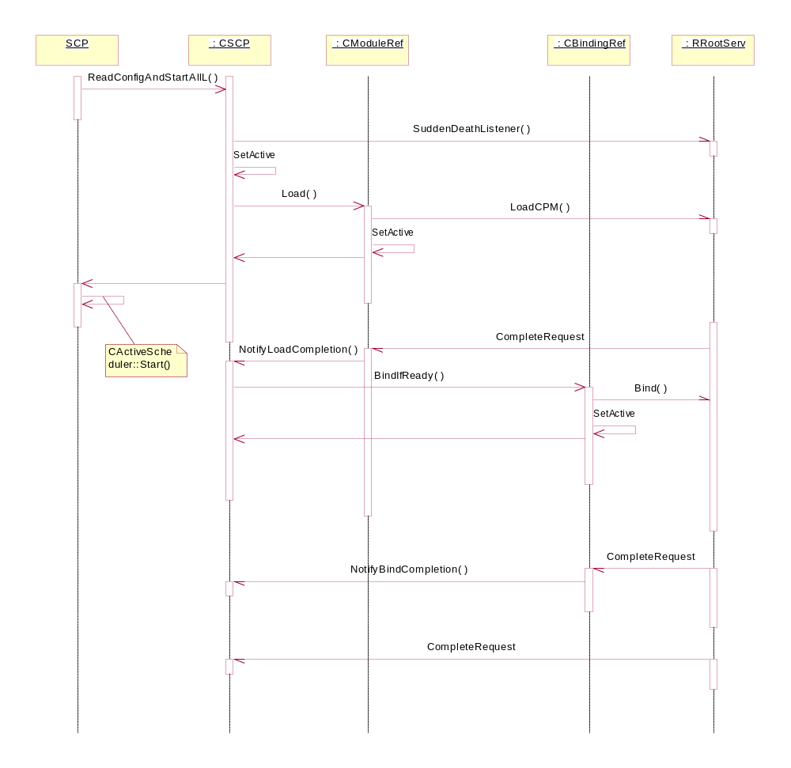
Figure 1: Load, Bind, and Die visualisation
The diagram shows an abridged sequence from the start of the SCP to the sudden death of a module:
- ReadConfigAndStartAllL() requests SuddenDeath notification.
- ReadConfigAndStartAllL() calls Load() upon each of the CModuleRefs it created from reading the config (creation of CModuleRefs and CBindingRefs not shown). The outcome of the load is asynchronously signalled back via NotifyLoadCompleted()
- Upon completion of ReadConfigAndStartAllL() the SCP main starts the active scheduler.
- Upon NotifyLoadCompleted() all unbound RBindingRefs are requested to bind if they can.
- When a module dies suddenly the SuddenDeath notifier completes.

Global Configuration Options
The .CMI files provide for the configuration of individual CPMs. Another configuration file, C32Start.INI, exists to host options for both the SCP behaviour and the CRS global behaviour. At present both this file and all of the settings are optional.
C32Start.INI has a single globals section, headed [Global], which may contain these options:

MBufPoolSize
Optional integer. When present, specifies the pool size for MBufs in bytes (default is 256kB, ie 262144).

TestMode
Optional integer. When present, specifies whether the SCP runs in test mode. In test mode the death of a module is merely logged, even when the module was marked as “SystemCritical”.

Design Considerations

Handling CPM “sudden death”
Note that although “sudden death” is the term used in the CRS design and API, in fact all deaths are handled by it, ie a notification also happens where the shutdown was explicitly commanded. It’s best to think of it as being analogous to the RUndertaker. The completion code indicates how the death occurred, ie whether it was in fact “sudden”. Note also that the notification is “one-shot”; completion will occur when a module dies and it’s up to the client to re-request completion to get a further notification. This also means that multiple deaths can occur with just a single completion.
The CRS responds to the death of a CPM thread by unbinding it, notifying the client of the death, and then deleting the CPM instance. Options for responding to the death notification are:
- Tell the user in some way (eg Panic, at least during development) and otherwise ignore the situation, ie the CPM remains dead. This may in turn mean that other CPMs are effectively dead, eg in the case of a low level protocol such as IP or a NIF. To recover from this state the user would have to restart the SCP, which would generally mean rebooting the device.
- Restart the CPM and recreate its bindings. This needs to be subject to some limitation, since otherwise a bad module will generate an endless loop. The proposed mechanism is to keep a counter of sudden deaths against each CPM, which decrements upon each death and is persisted in the CRS INI file, and only restart the CPM if this counter > 0. This would give tolerance for a transient fault, eg network conditions triggering an obscure defect in the SMS module. Resetting of the sudden death counter could simply be done via whatever user interface is provided for CPMs (for installation and removal), or on the basis of elapsed time (eg after the CPM has run for 24 hours).
This design follows the first option (panic) to avoid scope creep. Experience of the results of this may lead to improvement in future releases (or licensee products). The following sub-sections are presented as food for thought for the future:

Memory footprint
Because the Startup Process runs forever consideration needs to be given to ensuring a small footprint. Presuming that it runs from ROM then the goal is minimise the data requirements (alternatively, if the code was to be copied to RAM and run then partitioning the CPM loading code into a separate DLL would be a worthwhile approach, so that the normal footprint was only the sudden death handler. Caveat on this: if the loading & binding code was much smaller than a page of memory then it wouldn’t be likely to help).
A possible approach for this would be using a separate heap for all allocations relating to the CPM loading and binding (including parsing the CRS INI file). This heap could then be RHeap::Close()’d to free the memory. Alternatively, ensuring that all such transient allocations are not interleaved with other allocations would mean that a RHeap::Compress() should be able to reclaim the committed space at the top of the heap.
This is not an area of primary importance but needs some consideration, if only to try to avoid having memory committed equal to rather more than the sum of the contents of the .CMI files for absolutely no benefit.

Platform Security
The SCP runs with the NetworkControl capability, which it needs to interact with the CRS. Because it does not directly load any modules their capabilities do not effect it. The location of the configuration files is an issue, especially where the INI data in the .CMI file is the name of a further configuration file, since data caging requirements may dictate that these are in separate directories.

Life-long configuration process
If death is to be intelligently handled by the SCP then this is good argument for there being no other client of the CRS manipulating the configuration, since it introduces co-ordination problems (eg consider the case where the other client loads another module, which then panics: the SCP will get notified of a death but upon enumerating its list of loaded modules will find them all running. Or if the other client restarted a CPM with modified parameters, and it then died, the SCP would relaunch it with the originals.)
A plausible sounding approach that was briefly drafted into this design before elimination as unnecessary feature-creep is to have the SCP updating the running configuration to match that configured via the CMI files in cases such as a death-notification or an explicitly published change notification which a control panel or installer could use to enact changes made to the CMI files:
- If there is a CMI file not matched by a loaded module it is loaded (unless previously loaded and the maximum failure count has been reached, see 6.4.1).
- If there is a loaded module not matched by a CMI file then it is unloaded.
- If the current bindings don’t match the specified ones (eg due to CMI file change or loading of a module in (1) ) then bindings are requested (or removed.)
- If other parameters are changed (such as thread priority or INI data) then the module may need to be reloaded. This could be accomplished by having an update number in the CMI file.

Failure tolerance
In the current design a module suffering unexpected death will not be reloaded until the device reboots (or some other process uses the CRS API to reload and rebind it). This fits the model that this is a startup-configuration process but is arguably too harsh for a real world in which an otherwise reliable CPM might die in some rare and specific circumstances. The CMI keys could be extended to provide for some limited number of restarts, in conjunction with a “lockout” period, eg after a week of uptime a module’s failure count can be reset. This will balance the need to prevent a bad module from looping through reloads endlessly with that of not forcing a reboot to fix a very rare and transient problem.

Further Information

People
Role | Person / People
Contributor(s)
Reviewer(s) | Klaus Nielsen

References
No. | Document Reference | Version | Description
[R1] | “UML Explained” |  | by Kendall Scott  (http://www.amazon.co.uk/exec/obidos/tg/stores/detail/-/books/0201721821/toc/202-4456432-1159001)
[R2] | Root Server Design Document | Latest | Root Server Design Document
[R3] | GT140 Security “HowTo” Document | Latest | No document number; stored in GT140 project folder

Open Issues
None

Glossary
The following technical terms and abbreviations are used within this document.
Term | Definition
CPM | Comms Provider Module
CRS | Comms Root Server
SCP | Comms Root Startup Start/Configure Process (the subject of this design)

Document History
Date | Version | Status | Description
28-06-2002 | 0.1 | Draft | First draft based on SGL.PPS001.457 Component Design Document Template Rev 2.0
01-07-2002 | 0.2 | Draft | Incorporating Klaus Nielsen’s informal review remarks
01-08-2002 | 0.4 | For Review | Incorporating formal review remarks
13-08-2002 | 1.0 | Issued | Incorporates some further pointers for future directions
11-12-2002 | 1.1 | Issued | Updated section 3.1.1.7 to reflect changes to bindings on sub-modules, rather than modules.
12-12-2002 | 1.2 | Issued | Updated to include option for modules to use a private heap
06-02-2003 | 1.3 | Issued | Added new heap option details
11-02-2003 | 1.4 | Issued | Updated to include new CMI file sections and layout
21-02-2003 | 1.6 | Issued | Updated to include new ThreadOptionOrdinal option in the .CMI files.
10-04-2003 | 1.7 | Issued | Update to include new IsSticky option in the .CMI files.
06-11-2003 | 1.8 | Issued | Fixed spelling error.
08-11-2003 | 1.8 | Issued | Removed reference to GT138.
16-12-2003 | 1.9 | Issued | Added section 5, Global Configuration Options
16-05-2005 | 1.95 | For review | SSA adaptations are reflected
07-02-2006 | 2.0 | Issued | Minor fixes and belated status change

